PROJECT PROPOSAL

NIHVA TECHNOLOGIES PVT. LTD.
187, G-Block, Thermax chowk, Above Renault Showroom, MIDC
Chinchwad, Pune – 411019.

NIHVA Quotation No: - SQT/18-19/1049 Date: - 12.12.2018

Customer Name | HESPERUS AUTOMATION SYSTEMS PVT. LTD
Project Name | Roller Conveyor & Telescopic Conveyor
Project Location | Delhi NCR
Contact Person Name | Mr. Sunil
Email Id | sales@hesperusinfo.com
Contact Number | +91-9841243026

Contact Person:
Ms. Pratiksha Prajapati
Mob No.: 7219207333
Mr. Shailendra
Mob No: 9168423687
Email id: info@nihva.com
Web: http://www.nihva.com

Project Title: Roller conveyor and Telescopic conveyor
Date: 12/12/2018
Dear Sir,
Thank you for the opportunity and trust shown on “NIHVA” your preferred partner for innovative solutions. This has reference to your below mentioned requirement as well as our subsequent communication; please find below our best offer.

Requirement: -
Daily transaction volume
- Plant 40000 cases towards dispatch from production to Console WH which is 100 mtr. away.
- Console WH - Inbound - 40000 cases & dispatch 40000 cases with 100% bar code scanning.
- Vehicles 18 nos per day - (required proposal for telescopic conveyor for the same) for loading with 9 MT-750 cases, 15 MT-1500 cases, 20 MT-2100 cases, 32ft Mxl -2600 cases
- WH size & dimension - 48X18X5 mtr. i.e. ~8000 SFT
Product Details: -
- Roller conveyor: -
Conveyor length | 100 mtr
Conveyor width | 600 mm
Roller dia | 100 mm
No of roller | 2000 Nos
Drive motor ( Bonfiglioli Make) | 0.5 hp
Qty | 20 nos
Speed of conveyor | 5 mtr / min
Weight of system | 7500 kg

- Telescopic Conveyor: -
Total length | 15000 mm
Collapsed length | 9000 mm
Telescopic boom 1 | 3500 mm
Boom 2 | 1500 mm
Boom 3 | 1000 mm
Hydraulic cylinder for lifting
Belt width | 400 mm
Drive motor ( Bonfiglioli Make) | 1.5hp and 2.25 hp
Conveyor weight | 650 kg

Images: -
- Roller Conveyor: -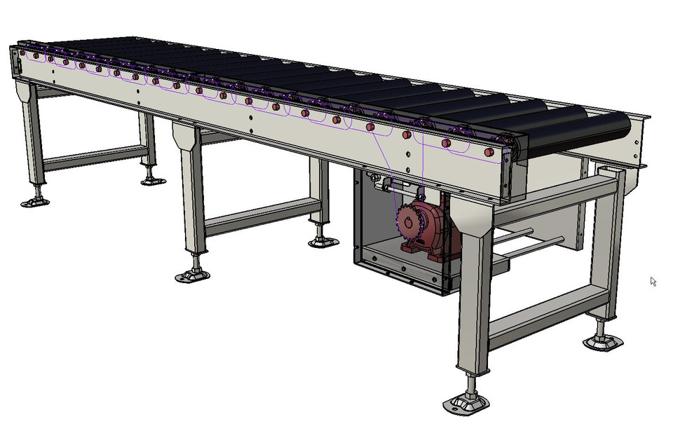

- Telescopic Conveyor: -

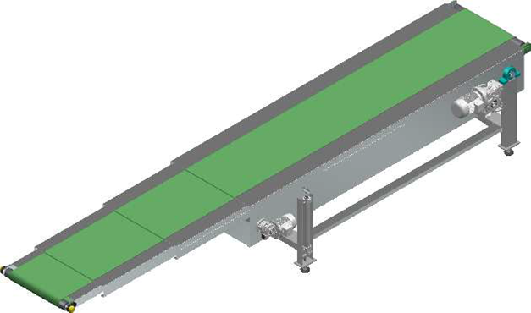

Commercial Offer: -

Sr no | Description | Qty | Unit | Rate in INR | Net Amount INR
1 | Roller Conveyor – 100 Meter | 1 | No | 74,13,000 | 74,13,000
2 | Telescopic Conveyor – 20 MT | 1 | No | 12,45,000 | 12,45,000
Total Supply |  |  |  |  | 86,58,000
Total Installation |  |  |  |  | Included
Total Supply + Installation |  |  |  |  | 86,58,000/-

GST PUNE: 27AAECN0437H1ZM
Drawings Training and warranty: -

Drawing:
We will issue a full set of drawings for approval within 2 weeks of receiving the confirmed order and finalized design details.

Training:
After installation of the Conveyor system, we will train the Clients personnel in the operation and basic maintenance, including the understanding of the error codes on the control system (if applicable).

Warranty:

The warranty period is twelve months from the date of installation and commissioning.
- If a defect arises within the warranty period stated, which is attributable to faulty design, materials or installation workmanship the product will be repaired at our discretion without charge.

- This guarantee is subject to proper use of the product and assumes that the product is regularly serviced and maintained by skilled personnel in accordance with the operation and maintenance instructions supplied.

- Maintenance & Service Agreement: -
We would suggest that you take advantage of a maintenance and service agreement on the NIHVA products, which will guarantee trouble free operation and speed of response in an emergency. Customized proposals are available on request.
We are pleased to inform that we also undertake AMC for all of our products & for any of your existing facilities.

Maintenance and service aren’t about what you get. They’re about what you avoid: failures, losses and unplanned interruptions.

- Client Scope: -
- Unloading from truck placement on site.
- Exiting/Repair/ Modification/ Refurbishment charges will be extra.

Terms and Conditions: -
- Price : Ex. Works Pune
- P & F : 3 % Extra at the time of delivery.
- Freight Notes : Extra as applicable.
- Delivery : Within 10- 12 weeks from date of receipt of confirmed purchase order,
advance payment, drawing approval.
- Payment Terms: 80% advance along with confirmed purchase order & balance before dispatch
- Insurance : Extra as applicable.
- GST : Extra @ 18%.
- Validity : 15 days from date of quotation.
- Warranty : 12 months from date of supply.

Please feel free to contact Mr. Ravi Ranjan Prasad – 7709586333 for any further clarification in this concern.

With Best Regards,
Pratiksha Prajapati
For NIHVA Technologies Pvt Ltd

